Kypton Lantz. Stella Kemp, Julio Pochet Edmead
11/5/2025
CSD460-O307 Capstone in Software Development (2261-DD)
Module Assignment 5.1: Database Dev

https://github.com/Stella-Elaine/Moffat-Bay/blob/main/database/schema.sql
Database login & table list:
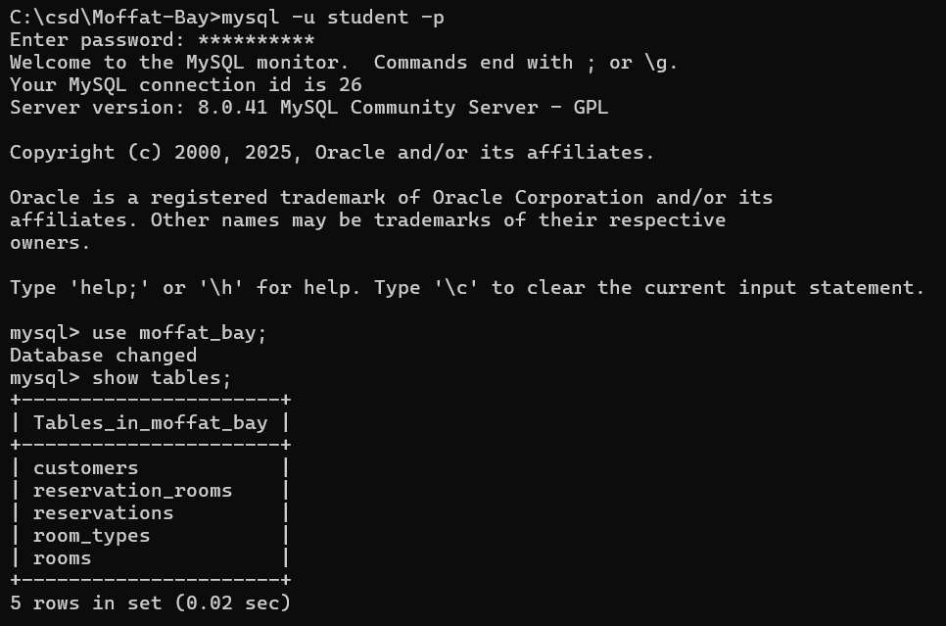
Select * from each table:
